Heaven’s light is our guide

Rajshahi University of Engineering & Technology



**Department of Computer Science & Engineering**

**Assignment**

Course Name: Digital Signal Processing

Course Code: CSE 3209

|  |  |
| --- | --- |
| Submitted by  Name:Kapil Deb Barman  Roll:2003181  Section: C  Series: 20 | Submitted to  Md. Farukuzzaman Faruk  Assistant Professor,  Department of CSE,  RUET |

**1.Introduction:**

This assignment focuses on fundamental DSP concepts, including

Discrete Fourier Transform (DFT), Discrete-Time Fourier Transform (DTFT), and Filtering. You will implement and analyze these concepts using Python.

**2.Basic Signal Operations:**

**2.1 Signal Generation and Transformations**

**Code:**

fs = 100

f = 5

N = 100

k = 10

a = 2

n = np.arange(N)

x = np.sin(2 * np.pi * f * n / fs)

x_shifted = np.roll(x, k)

x_reversed = x[::-1]

n_scaled = np.arange(0, N, a)

x_scaled = x[n_scaled]

plt.figure(figsize=(12, 8))

plt.subplot(3, 1, 1)

plt.stem(n, x, linefmt='b-', markerfmt='bo', basefmt='k', label='Original x[n]')

plt.stem(n, x_shifted, linefmt='r-', markerfmt='ro', basefmt='k', label=f'Shifted x[n-{k}]')

plt.xlabel('n')

plt.ylabel('Amplitude')

plt.title('Time Shifting')

plt.legend()

plt.grid()

plt.subplot(3, 1, 2)

plt.stem(n, x, linefmt='b-', markerfmt='bo', basefmt='k', label='Original x[n]')

plt.stem(n, x_reversed, linefmt='g-', markerfmt='go', basefmt='k', label='Reversed x[-n]')

plt.xlabel('n')

plt.ylabel('Amplitude')

plt.title('Time Reversal')

plt.legend()

plt.grid()

plt.subplot(3, 1, 3)

plt.stem(n, x, linefmt='b-', markerfmt='bo', basefmt='k', label='Original x[n]')

plt.stem(n_scaled, x_scaled, linefmt='m-', markerfmt='mo', basefmt='k', label=f'Scaled x[{a}n]')

plt.xlabel('n')

plt.ylabel('Amplitude')

plt.title('Time Scaling')

plt.legend()

plt.grid()

plt.tight_layout()

plt.show()

**Result:**

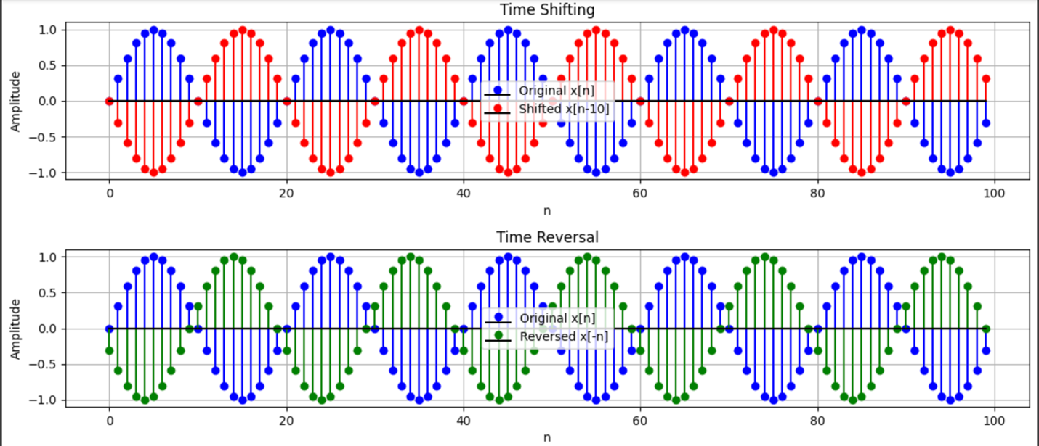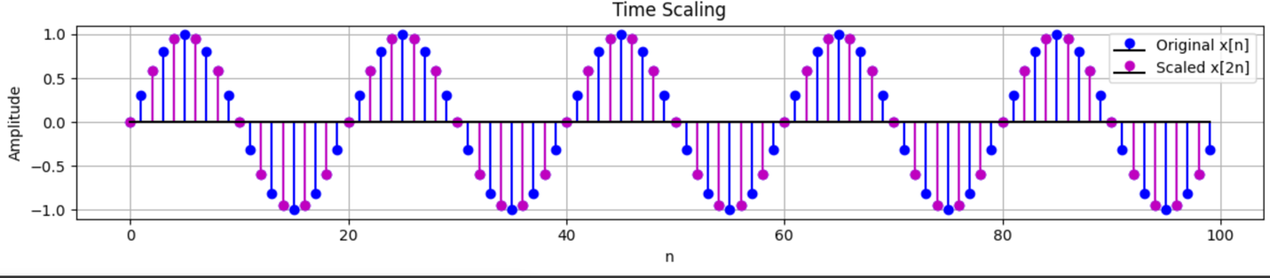

**3.Discrete Fourier Transform (DFT)**

**Code:**

def DFT(x):

N = len(x)

X = np.zeros(N, dtype=complex)

for k in range(N):

for n in range(N):

X[k] += x[n] * np.exp(-2j * np.pi * k * n / N)

return X

X_manual = DFT(x)

X_numpy = np.fft.fft(x)

plt.figure(figsize=(10, 4))

#plt.subplot(3, 1, 1)

plt.plot(np.abs(X_manual), 'bo-', label='Manual DFT')

plt.plot(np.abs(X_numpy), 'r--', label='Numpy FFT')

plt.xlabel('Frequency Index')

plt.ylabel('Magnitude')

plt.title('DFT vs Numpy FFT')

plt.legend()

plt.grid()

plt.show()

**Result:**

**4.Discrete-Time Fourier Transform (DTFT)**

**Code:**

omega = np.linspace(-np.pi, np.pi, 1000)

X_dtft = np.array([np.sum(x * np.exp(-1j * w * n)) for w in omega])

plt.figure(figsize=(10, 4))

plt.plot(omega, np.abs(X_dtft), 'g-', label='DTFT')

plt.xlabel('Frequency (rad/sample)')

plt.ylabel('Magnitude')

plt.title('DTFT Magnitude Spectrum')

plt.legend()

plt.grid()

plt.show()

**Result:**

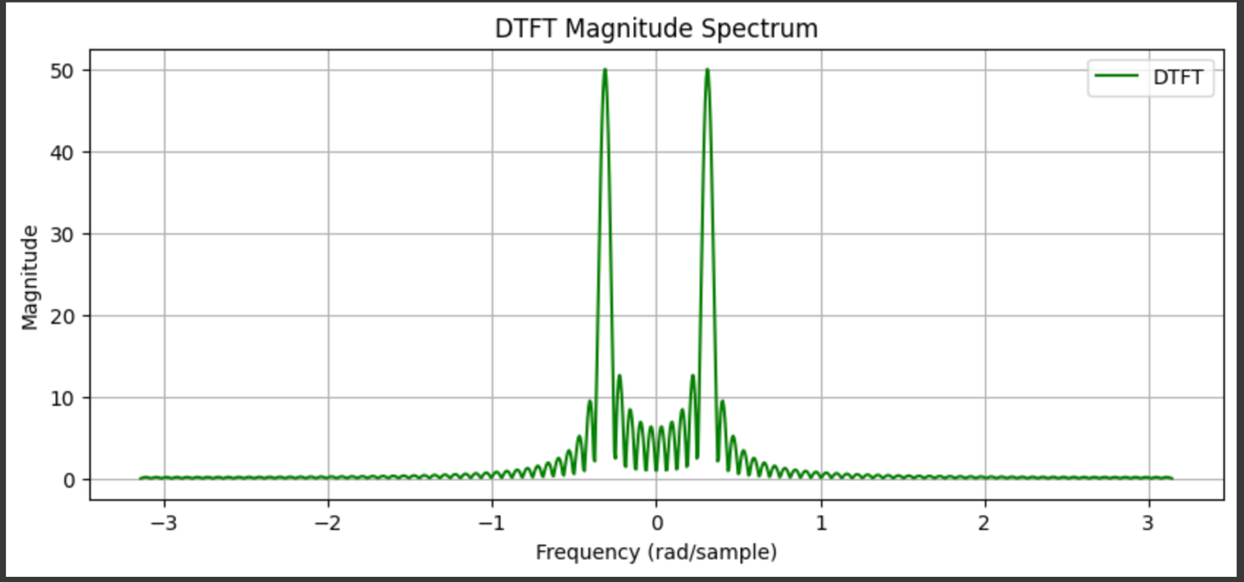

**5.Fast Fourier Transform (FFT) Efficiency**

**Code:**

sizes = [64, 128, 256, 512, 1024]

dft_times = []

fft_times = []

for N in sizes:

x = np.random.rand(N)

start_time = time.time()

X_manual = DFT(x)

dft_times.append(time.time() - start_time)

start_time = time.time()

X_numpy = np.fft.fft(x)

fft_times.append(time.time() - start_time)

plt.figure(figsize=(8, 6))

plt.plot(sizes, dft_times, label='DFT ', marker='o', linestyle='--', color='r')

plt.plot(sizes, fft_times, label='FFT ', marker='s', linestyle='-', color='b')

plt.yscale('log')

plt.xlabel('Input Size (N)')

plt.ylabel('Execution Time (seconds)')

plt.title('DFT vs FFT Execution Time')

plt.legend()

plt.grid()

plt.show()

**Result:**

**6.Filtering in the Frequency Domain**

**Code:**

f_c = 10 #cutoff

def low_pass_filter(X, fs, cutoff_freq):

N = len(X)

freqs = np.fft.fftfreq(N, 1/fs)

filter_mask = np.abs(freqs) <= cutoff_freq

X_filtered = X * filter_mask

return X_filtered

X = DFT(x)

X_filtered = low_pass_filter(X, fs, f_c)

def IDFT(X_filtered):

N = len(X_filtered)

x_filtered = np.zeros(N, dtype=complex)

for n in range(N):

for k in range(N):

x_filtered[n] += X_filtered[k] * np.exp(2j * np.pi * k * n / N)

return np.real(x_filtered)

x_filtered = IDFT(X_filtered)

plt.figure(figsize=(12, 8))

plt.subplot(3, 1, 1)

plt.stem(n, x, linefmt='b-', markerfmt='bo', basefmt='k', label='Original x[n]')

plt.xlabel('n')

plt.ylabel('Amplitude')

plt.title('Original Signal')

plt.legend()

plt.grid()

plt.subplot(3, 1, 2)

plt.stem(n, x_filtered, linefmt='r-', markerfmt='ro', basefmt='k', label='Filtered x[n]')

plt.xlabel('n')

plt.ylabel('Amplitude')

plt.title('Low-pass Filtered Signal')

plt.legend()

plt.grid()

plt.tight_layout()

plt.show()

**Result:**

